Hist 438: Neighboring Worlds
Humanity’s History in the Solar System

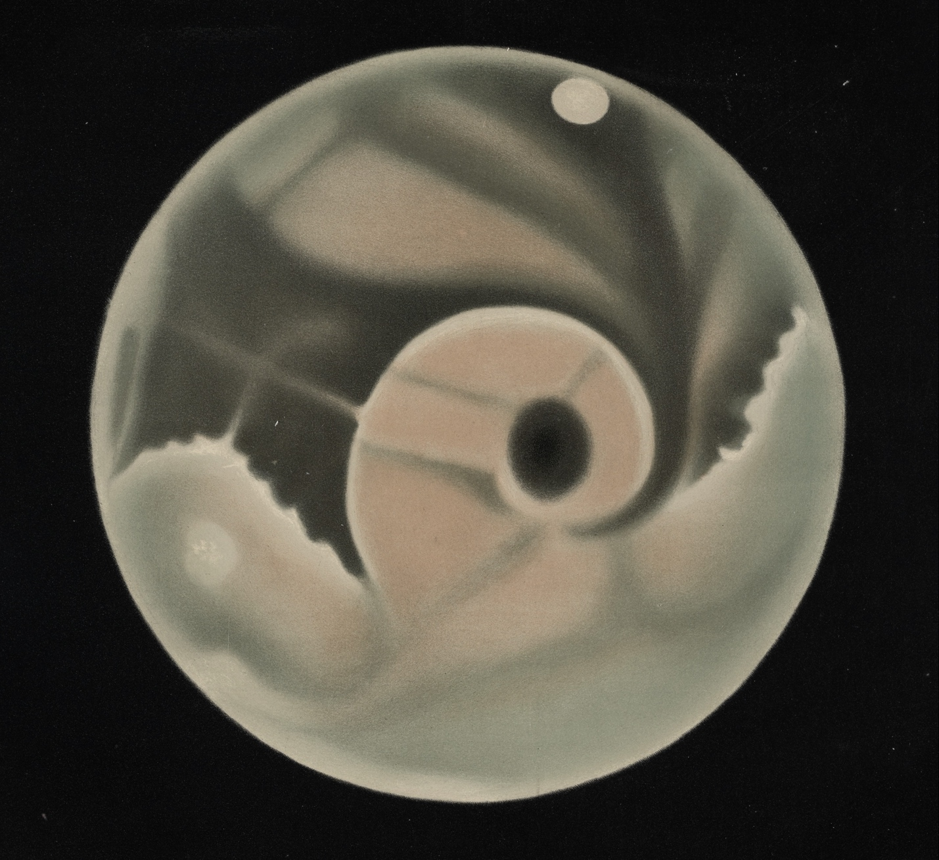

Essential Information:

Classes: Tuesdays and Thursdays, 9:30-10:45 AM EST, CBN 302A.
Office Hours: Tuesdays, 11:00 AM-1:00 PM EST, on Zoom or in ICC 610.
Professor: Dr. Dagomar Degroot. Email: dd865@georgetown.edu. Web: DagomarDegroot.com.
Course Website: NeighboringWorlds.weebly.com.

Course Description:

We may be on the verge of a new era of human expansion into outer space. Space agencies around the world have committed themselves to establishing settlements on or near the Moon, and are building enormous rockets to make that possible. Spacecraft have revealed cosmic environments to be more active and alien places – with more dynamic histories – than scientists previously imagined. Companies led by ambitious tycoons are now introducing revolutionary technologies that could allow them to reach, and perhaps even inhabit, the Moon, Mars, and possibly Venus.
This course will guide you through the history and present-day reality of this new era. You will discover, among other topics, how the Sun’s variability has helped shape human evolution and history; how early astronomers mapped and often misinterpreted environments on the Moon, Mars, and Venus; and how sudden environmental changes on Earth and on Mars provoked sightings of canals – and fears of alien invasion – across the western world. You will learn about the twin “space races” that led humans to the Moon and robots further afield; the plans to establish military bases on the Moon; the Martian dust storm that inspired the idea of nuclear winter on Earth; the shocking greenhouse effect on Venus that strengthened theories of global warming on Earth; and the history of a radical dream to turn Mars – and perhaps Venus – into a world like Earth. You will also study the history of the quest for life on Mars, the Moon, and Venus, and appraise the schemes to mine the rich resources of asteroids to save our world from environmental catastrophe. Along the way, we will consider the morality and meaning of what may be the next great leap for our species.

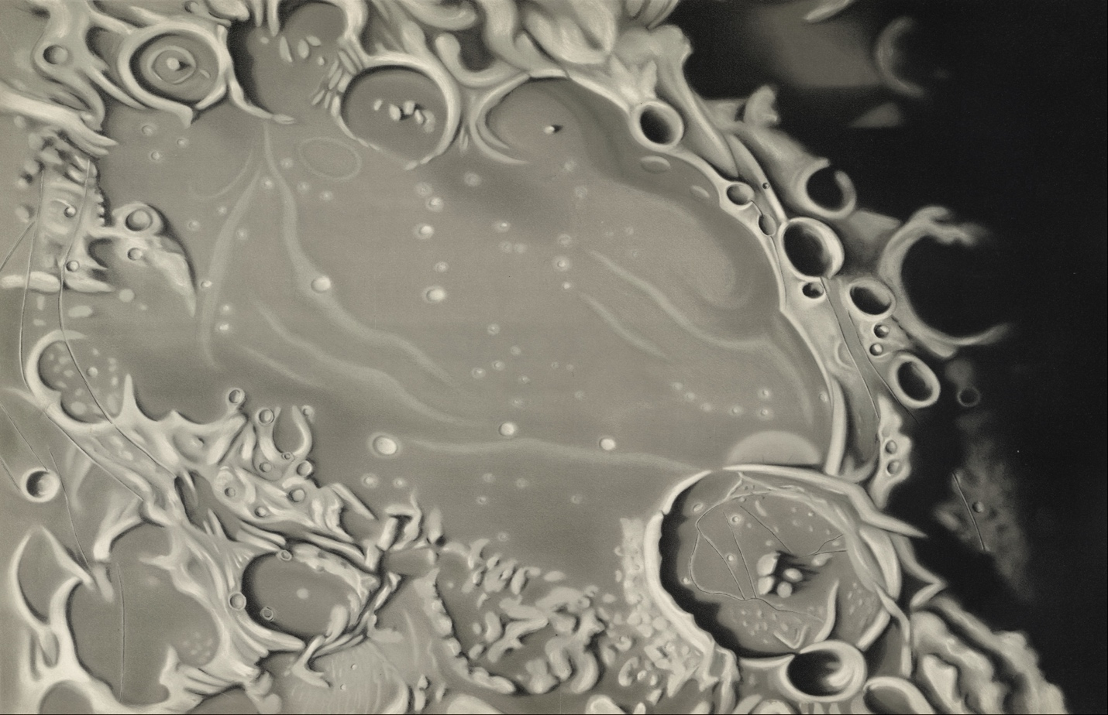
Course Goals:

Like other courses offered by the Department of History, this course will help you:

- Gain a deeper appreciation of the nature and practice of history as a discipline, and as the study, based on evidence, of human experiences, interactions, and relationships as they change over time.
- Learn that history does not consist of a simple succession of self-evident facts, and that evidence-based interpretation and analysis are central to all historical work.
- Hone reading, writing, and oral communication skills.
- Develop your capacity to think historically: to situate events and developments in their historical context for the purpose of critical analysis.
- Expand your ability to engage with complex causal analysis, and to articulate arguments that integrate supporting evidence and analytical commentary.
- View the world from perspectives other than your own.

This course in particular will also help you:

- Understand now different academic disciplines approach the human past, and what their distinct methods and sources can tell us.
- Learn the history that will help you make sense of how space agencies and companies are exploring, and plan to exploit, the worlds closest to Earth.

Breakdown:

Participation: 30%
5-page Moon Essay (due October 6th): 15%
Settlement Essay Annotated Bibliography (due November 3rd): 10%
15-page Settlement Essay (due November 29th): 40%
Settlement Essay Presentation (beginning November 29th): 5%

Evaluation:

You will submit all assignments on Canvas. You will be able to access additional assignment resources on our course homepage.

Participation:

You will earn half of your participation grade just for attending class. The other half will reflect the quantity and especially the quality of your comments. If we break into groups for debates and primary source exercises, I will evaluate your group participation. If you want top grades, I strongly encourage you to keep notes from your readings. You should aim for at around two pages of single-spaced notes per week.

Moon Essay:

I’ll set up at least one telescope on campus. Sometime in the evening, you’ll join me and peer through the telescope, which should give you a striking view of the Moon. You will do your best to identify an “environment” – a distinct lunar feature – that interests you, or that has come up in our readings. Your task is to consider the human history of that feature.

You will write a five-page paper that explains how, why, and when your feature – your environment – has been observed, studied, explored, interpreted, and imagined historically. You will use only secondary sources – and your own observations – to write your essay (you may use course readings). You must use at least three secondary sources. We will discuss how to write the essay class. I encourage you to send me questions via email, or meet with me via Zoom, as you draft your essay.

If you want to observe the Moon after or before looking through the telescope, I encourage you to buy some binoculars. Just about any pair will give you an impressive view; I particularly recommend Celestron Cometron 7x50 Binoculars.

Settlement Essay:

Imagine a scenario in which the United States or the Soviet Union had attempted to settle the Moon, Mars, or Venus in the 1970s. Ask yourself:

- What social, political, or economic forces needed to align to make such a program possible in either country?
- What world – Mars, Venus, or the Moon – would policymakers, bureaucrats, engineers, and scientists have chosen to settle? What discrete environment in each world would they have targeted for settlement?
- What technical and practical obstacles would the Soviet or American space programs have had to overcome to settle in this environment?
- Would a settlement attempt have succeeded? What would have been the historical significance of the effort?

Remember: this is a history paper, which means that you need to examine historical relationships by analyzing historical sources. But it is also an interdisciplinary paper, because it requires you to draw on disciplines beyond history – including, especially, planetary science. Note that while I expect you to do your best in answering these questions, I am not expecting a particular answer. You will be graded for your reasoning, argumentation, and your use of sources, not for providing the right response.

The trick to completing this assignment will be to craft a thesis – an argument – that effectively combines your answers to these questions. We’ll discuss how to do that in class. The assignment also consists of several steps that will allow me to guide you through the process of writing it – and then let you communicate your findings to your peers.

Annotated Bibliography:

First, find at least one primary source that will help you compose an argument relevant to these questions. For a guide to reading primary sources, click here (if you’ve printed out this syllabus, the link is: http://users.clas.ufl.edu/sterk/junsem/reading.html). Your interpretation of your primary source(s), and your investigation of the history it allows you to examine, should be supported by secondary sources: that is, scholarship written about your topic.

Now, plan out your essay in an annotated bibliography. In your first page, provide a preliminary thesis statement that you will defend using your primary and secondary sources (this should be no longer than a paragraph). Now, list and describe your primary source(s). This should be no longer than a page.

List your secondary sources on the following pages. These sources should cover an issue relevant to the hypothesis you have presented. They should be written after 1975, unless I approve your use of an older source. You should use no fewer than seven books, with one book equaling two articles (in other words, you can use four books and six articles, for example). Each secondary source citation should be accompanied by a short paragraph clearly stating its argument, the strengths and weaknesses of that argument, and how it compares to the positions taken in your other secondary sources. In every source description – including your description of your primary source – explain how the source will help you defend your thesis.

I strongly recommend that you contact me at least one week before the annotated bibliography due date to confirm your topic with me. I am happy to offer suggestions for where you might look for primary sources.

Essay:

After I return your annotated bibliography with my grade and recommendations, you will begin drafting your essay. I encourage you to meet with me as you write the essay, and to begin writing well before the submission deadline. Your completed essay should be 15 pages long and no more than 4,000 words (see below for formatting instructions). You may include images, but they will not count towards your page total.

Presentation:

After you submit your essay, you will give a short (5-minute) presentation to the class that explains how you answered the questions I posed.

Formatting your Essays:

Make a title page! Your title page should have your assignment title in large, centered font. Your name, your class name, my name, and the date should be in a smaller font at the bottom right of your title page. Note that your title page is not included in your page count.
Your papers should be written in size 12, Times New Roman font. They should be double-spaced. You should use standard margins (one inch on all sides of the document). Number your pages (at the top right).
Use formal academic writing (no contractions or colloquialisms).
Cite all sources using Chicago Style formatting, which means that you need footnotes and a bibliography (note that the bibliography does not add to your page count). Click here to find out how you do this. You should always cite at the end of a quotation. Otherwise, include all citations in a footnote at the end of a paragraph. You do not need to cite every sentence. Your footnotes should be numbered sequentially and they should be single-spaced.
Grading Criteria:

Each of these criteria will be worth approximately a third of your grade:

Clarity:

Are you using words that appropriately and formally express your meaning? Are your points sourced correctly? Do your sentences precisely express your meaning, and are they grammatically correct? Is there a clear thesis that presents an argument and outlines how that argument will be defended? Is there a coherent organization that culminates in a conclusion that references the thesis?

Research:

Are your secondary sources serious works of scholarship, and are they relevant to your argument? Do your primary sources illuminate the issue you are investigating, and to what extent? Are those primary sources relevant to your argument, and do you present them in the context of your secondary sources?

Ideas:

How creative and nuanced are your arguments? Are you merely repeating the claims of other scholars, or are you evaluating them in the context of other arguments and concepts? To what extent can you develop fresh ideas?

Value of Letter Grades:
A = 95-100
A- = 90-94
B+ = 87-89
B = 83-86
B- = 80-82
C+ = 77-79
C = 73-76
C- = 70-72
​ETC.

​Meaning of Letter Grades:
Courtesy of Professors Amy Leonard, Howard Spendelow, and Alan Karras​:
​
A Outstanding. We’ve looked and looked for errors and found perhaps a few lapses in grammar, but they are insignificant because you raised an interesting and important argument. You followed all the directions of the assignment and wrote in a clear and fluid manner. You cited your sources and garnered good evidence for your argument. In most courses, an average of no more than 10% of students receive an A as a final grade.
A- Excellent. You show a superb mastery of the materials. Your paper has a clear argument but something is just a little bit off, and consistently so. You need some tightening of argumentation, for example, or you should have pushed your data that extra step. Or, there are some writing flaws in your paper or, your organization might not be perfect and obscures your otherwise fine argument. Nevertheless, an A- is a very good grade.
B+ Very good. You've clearly learned the material and there are no major errors. But your answer is lacking in originality, clarity, or sparkle. In some cases, this grade can be for a brilliant essay with significant and frequent writing flaws.
B Good. You have a solid argument but it is not fully developed. Your argument is plausible but you need more supporting evidence to make a convincing case. Or, you’ve given the right evidence but haven’t articulated the argument. Or in an exam, for example, the chronology is confused or in a paper, there are problems with annotation and the use of sources. These are not fatal.
B- Pretty good. Your answer is solid, but incomplete. You end the paper or essay where you should begin it. Your essay has the right elements but they are in the wrong order. Your argument is likely missing something and might also have some problems in expression. I might have to strain to figure out what you want to say but once I do, it makes sense. This strain suggests that you could have corrected the problem with more attention to your argument.
C+ Fair. It's not obvious that you've done the readings and listened to the lectures. What you say might be true, but it is unclear since your argument has many writing problems and a reader has to work overtime to figure out what you mean. Your argument, though plausible, is not especially deep or insightful. The paper has errors and an imbalance between generalizations and
evidence. There are problems with annotation that suggests attention has not been paid to the detail and mechanics of writing a paper.
C Acceptable, but...
- You might have grasped the basic idea, but have missed the main focal points of the questions and/or;
- There are omissions or disturbing errors in fact or your logic is flawed and/or;
- Although basically correct, your argument has no supporting evidence and/or;
- Your writing is obscuring your argument, your notes are inadequate, and your credibility is not so good either.
C- Still acceptable, but here are a greater number of problems and/or a fewer number of good points than needed to earn you a “C.” In other words, more of the C problems (mentioned above) are true in a C- paper.
D+ Barely acceptable. There are serious errors, omissions, or inconsistencies here, but the light of understanding somehow, occasionally, flickers through.
D Just barely acceptable. Your answer is so vague that it's hard to find something good to say. Your writing problems also are pretty significant.
D- Passing. Be grateful your instructors are nice people with a great deal of patience. Perhaps you need to spend more time on your answers/papers next time! Asking for help might also be a good idea.
​F Don’t think so. There's not even enough here about which to be patient. At least you will get some credit for your effort, which is better than the zero you would have gotten for leaving the answer blank.

Important Notes:

Course Resources:

There are three resources you should familiarize yourself with in this course. The first is this syllabus. Before asking me a question about the course, please consult the syllabus.
The second resource is our Canvas page. On the page, you’ll be able to submit your assignments and download any readings you can’t access through our library resources. You’ll also be able to access our office hours.
The third resource in our course website (you can find a link on the first page of this syllabus). The website will host a regularly updated version of the syllabus, alongside resources for completing your major essay.

House Rules:

You may use your laptops or tablets to take notes or to look up information in class. However, you may not use your phones, and you may not record your professor’s lectures. Please do not access social media in class; it’s distracting both for you and for your classmates.

Do not show up late to class. This detracts from your learning and disturbs your classmates. If you are repeatedly late, I may lower your participation grade without informing you.

Submitting Assignments:

All assignments should be submitted on Canvas, and all are due at midnight on the due date. Late assignments will receive a 2%/day penalty. I will not grade assignments that are more than one week late, unless you have negotiated an extension with me (see below).

Extensions:

You may ask me for a short extension before an assignment is due. I will likely grant your request if you A) give me a convincing explanation for why you’re late; B) give me a roadmap that outlines how you will complete your assignment; and C) propose a new due date.

I will only grant requests for an extension on or after the assignment due date in exceptional circumstances (a serious illness, for example). Be sure to contact your deans in case of absences, difficulties meeting due dates, and other problems.

Missing Assignments:

If you fail to hand in an assignment, you will receive a zero for that assignment. Note that you will not necessarily receive a message from me that asks about your missing assignment; it’s up to you to keep track of the due dates in this course.

Missing Class:

You have only one excused absence per term. If you think that you will need to miss several classes for significant and predictable reasons (such as religious observances, or University-sponsored athletic events), you must inform me of the specific circumstances and dates at the start of the term.

I will try to accommodate requests for a reasonable number of such absences. You must make sure that the details of the situation are clear to me early on, so that you may have a chance to enroll in a different class if I cannot accommodate your circumstances. Note that the short length of this module will make it hard for you to do well if you must miss more than two classes.

You receive a grade for every class you attend. If you do not attend a class and you have already had your one excused absence, you will receive a grade of zero for the class you missed. This will significantly lower your overall grade.

Academic Honesty:

Plagiarism is not just about copying someone else’s writing. Any time you present ideas without correctly citing them, you are committing plagiarism. This is the most serious intellectual offense you can commit at a university, so your professors – me included – take it very seriously.

It is your responsibility to familiarize yourself with the Georgetown University Undergraduate Honor System. It is your professor’s duty to refer academic misconduct – including plagiarism – to the Georgetown Honor Council. If the Council decides that you have plagiarized on an assignment, you will fail that assignment – and you may fail the course.

Beyond the Course:

I am committed to supporting survivors of sexual misconduct, which includes relationship violence, sexual harassment and sexual assault. However, university policy requires faculty to report any disclosures about sexual misconduct to the Georgetown Title IX Coordinator, who directs the University’s response to sexual misconduct.

Georgetown has a number of fully confidential professionals who provide support and assistance to survivors of sexual assault and other forms of sexual misconduct. To connect with those professionals – including to report an incident – and to review our university policies, you can visit: https://sexualassault.georgetown.edu.

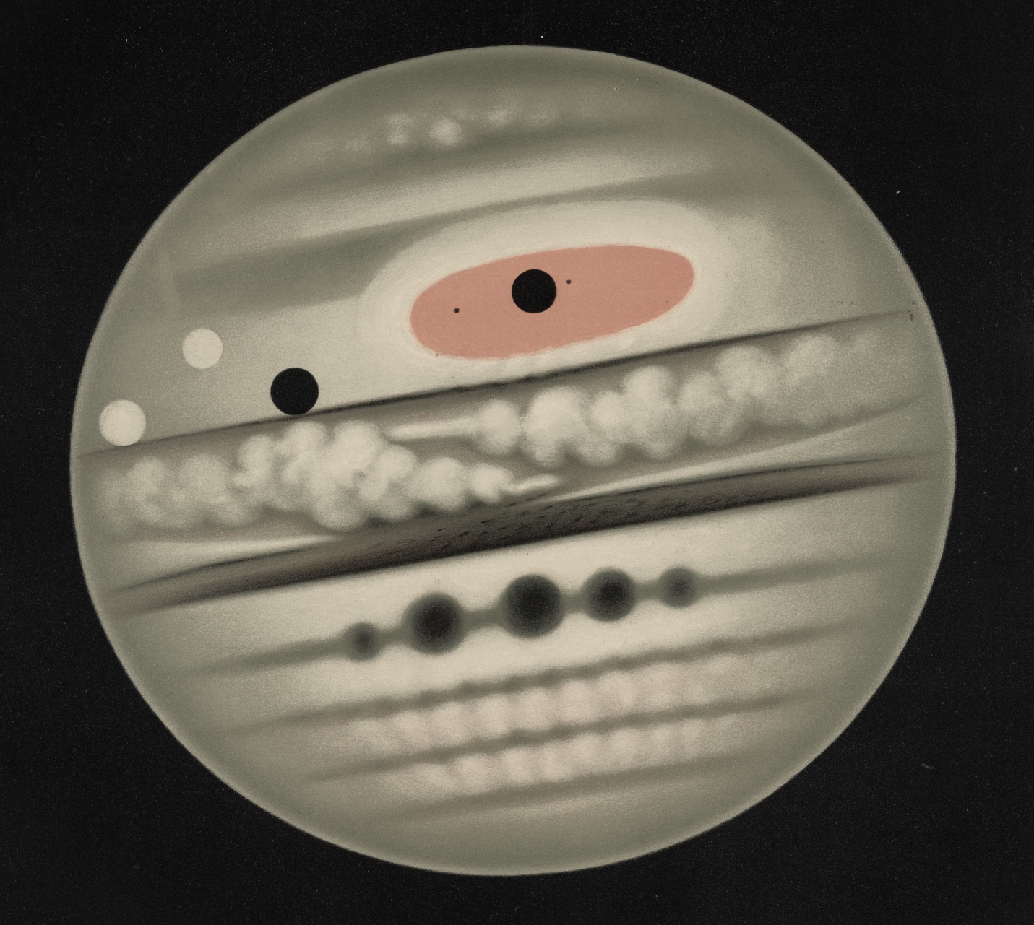
Schedule:

- This schedule may be changed by your professor. You will usually have at least one week’s notice.
- Please complete all weekly readings by Tuesday.
- These readings are color-coded: blue for secondary sources, red for primary sources.

PART I: INTRODUCTION

Week 1: An Overview of the Solar System

August 25: DO NOT COME TO CLASS. You will watch a course introduction video and brief lecture that will be available on Canvas.

Readings:

- Browse through “NASA Science Solar System Exploration.” Available at: https://solarsystem.nasa.gov/solar-system/our-solar-system/overview.

PART II: SUN

Week 2: Climate Change and the Variable Sun

August 30
September 1

Readings:

- Dagomar Degroot et al., “The History of Climate and Society: A Review of the Influence of Climate Change on the Human Past.” Environmental Research Letters. Available through Canvas.

Week 3: Solar Storms and Solar Sails

September 6: NO CLASS
September 8

Readings:

- Knipp, Delores J. et al., “The May 1967 great storm and radio disruption event: Extreme space weather and extraordinary responses.” Space Weather 14:9 (2016): 614-633.
- Bo Fu, Evan Sperber, and Fidelis Eke. “Solar sail technology—A state of the art review.” Progress in Aerospace Sciences 86 (2016): 1-19.
- Loeb, Abraham. “On the Possibility of an Artificial Origin for Oumuamua.” arXiv preprint arXiv:2110.15213 (2021).
- Browse through: Space Studies Board and National Research Council, Severe space weather events: Understanding societal and economic impacts. National Academies Press, 2009. Available through Canvas.

PART II: MOON

Week 4: Discovering and Militarizing the Moon

September 13
September 15

Readings:

- “Moon,” in Dagomar Degroot, Ripples on the Cosmic Ocean: An Environmental History of the Solar System. Available through Canvas.
- Read one of the following:
  - U.S. Army, Project Horizon, Vol. I: Summary and Supporting Considerations. 1959. Available through Canvas.
  - J. Reiffel, “A Study of Lunar Research Flights Vol. I.” Air Force Special Weapons Center, 1959. Available through Canvas.
- Read one of the following:
  - Sydney Wesley Finer, “The Kidnapping of the Lunik.” Available through Canvas.
  - CIA, “Preliminary Analysis of Luna-9 Photography.” June 1966. Available through Canvas.

Week 5: The Space Race and the Race to Protect Earth

September 20
September 22

Readings:

- Chapters 2 and 4-8 (that’s pages 39-58, and 89-214) in Roger Launius, Reaching for the Moon: A Short History of the Space Race. Yale University Press, 2019. Available as a free e-book through Georgetown library.
- Dagomar Degroot, “One Small Step for Man, One Giant Leap for Moon Microbes?: Interpretations of Risk and the Limits of Quarantine in NASA’s Apollo Program.” Isis. Available through Canvas.

Readings:

Week 6: Exploiting the Moon Today

September 27
September 29: Instead of coming to class, please attend at least one session in the “NASA and the Environment Conference,” from September 28 to September 29.

Readings:

- Leonard David, Moon Rush: The New Space Race. Washington, DC: National Geographic, 2019. Pages 106-196. Available as a free e-book through Georgetown library.
- “NASA’s Plan for Sustained Lunar Exploration and Development.” NASA. Available at: https://go.nasa.gov/3fpZiXv.

PART III: MARS

Week 7: Canals on a Dying World

October 4
October 6: MOON ESSAY DUE.

Readings:

- K. Maria D. Lane, “Geographers of Mars: cartographic inscription and exploration narrative in late Victorian representations of the red planet.” Isis 96:4 (2005): 477-506.
- Joshua Nall, “Constructing Canals on Mars: Event Astronomy and the Transmission of International Telegraphic News.” Isis 108:2 (2017): 280-306.
- Percival Lowell, Mars as the Abode of Life. Find it here: https://archive.org/details/marsabodeoflife00loweiala. Now read EITHER:
  - Chapter IV, “Mars and the Future of the Earth.”
  - Chapter V, “The Canals and Oases of Mars.”
  - Chapter VI, “Proofs of Life on Mars.”
- H. G. Wells, War of the Worlds. EITHER:
  - Read the original version: https://www.gutenberg.org/files/36/36-h/36-h.htm.
  - Listen to the radio broadcast: https://www.youtube.com/watch?v=Xs0K4ApWl4g.

Week 8: The Modern Quest for Life on Mars

October 11
October 13: NO CLASS

Readings:

- Chapters 4, 6, and 9, in Elizabeth Howell and Nicholas Booth, The Search for Life on Mars: The Greatest Scientific Detective Story of All Time. New York: Simon & Schuster, 2020. Available as a free e-book through Georgetown library.
- “Prologue” and “Part 3” in Sarah Stewart Johnson, The Sirens of Mars: Searching for Life on Another World. New York: Penguin Random House, 2020. Available as a free e-book through Georgetown library.
- Alberto G. Fairén et al., “Searching for life on Mars before it is too late.” Astrobiology 17:10 (2017): 962-970.
- Lisa Messeri, “Extra-terra incognita: Martian maps in the digital age.” Social Studies of Science 47:1 (2017): 75-94

Week 9: Settling and Terraforming Mars

October 18
October 20

Readings:

- Elon Musk, “Making Life Multi-Planetary.” New Space 6:1 (2018).
- Tanja Masson-Zwaan, “New states in space.” American Journal of International Law 113 (2019): 98-102.
- Matthew T. King and Laurie R. Blank, “International law and security in outer space: Now and tomorrow.” American Journal of International Law 113 (2019): 125-129.
- Bruce M. Jakosky and Christopher S. Edwards, “Inventory of CO 2 available for terraforming Mars.” Nature Astronomy 2:8 (2018): 634-639.
- Alfonso F. Davila, David Willson, John D. Coates, and Christopher P. McKay. “Perchlorate on Mars: a chemical hazard and a resource for humans.” Int. J. Astrobiol 12:04 (2013): 321-325.
- Frank Tavares et al., “Ethical Exploration and the Role of Planetary Protection in Disrupting Colonial Practices.” Available through Canvas.
- Browse through Wernher von Braun, “Project Mars - A Technical Tale.” Pages 7-214. Available at: https://archive.org/details/ProjectMars.

PART IV: VENUS

Week 10: Transits and Controversies

October 25
October 27

Readings:

- Preface and Chapters 7 and 8 in William Sheehan and John E. Westfall, The Transits of Venus. Amherst: Prometheus Books, 2004. Available through Canvas.
- Chapters 2 and 5 in Immanuel Velikovsky, Worlds in Collision. New York: Doubleday & Company, 1950. Available through Canvas.
- V. Bargmann and Lloyd Motz, “On the Recent Discoveries Concerning Jupiter and Venus.” Science 138:3547 (1962): 1350-1352.
- Alfred De Grazia, “The scientific reception system and Dr. Velikovsky.” American Behavioral Scientist 7:1 (1963): 45-49.
- Immanuel Velikovsky, “My Challenge to Conventional Views in Science.” AAAS Symposium, February 25, 1974. Available through Canvas.
- Carl Sagan, “An Analysis of Worlds in Collision,” in Scientists Confront Velikovsky. New York: W. W. Norton & Company, 1979. Available through Canvas.

Week 11: Discovering the Runaway Greenhouse Next-door

November 1
November 3: SETTLEMENT ESSAY ANNOTATED BIBLIOGRAPHY DUE

Readings:

- Selections from Frederic W. Taylor, The Scientific Exploration of Venus. Cambridge: Cambridge University Press, 2014. Available through Canvas.
- Carl Sagan, “The planet Venus.” Science 133:3456 (1961): 849-858.
- W. C. Wang et al., “Greenhouse effects due to man-made perturbations of trace gases.” Science 194:4266 (1976): 685-690.
- James Hansen, “The Venus Syndrome” in Storms of my Grandchildren: The truth about the coming climate catastrophe and our last chance to save humanity. New York: Bloomsbury, 2009. Available through Canvas.

Week 12: (Human) Life on Venus?

November 8
November 10

Readings:

- Pages 294-319 in David Harry Grinspoon, Venus Revealed: A New Look Below the Clouds of our Mysterious Twin Planet. Cambridge: Perseus Publishing, 1997. Available through Canvas.
- Jane S. Greaves et al., “Phosphine gas in the cloud decks of Venus.” Nature Astronomy (2020): 1-10.
- Charles S. Cockell, Sean McMahon, and Jennifer F. Biddle, “When is life a viable hypothesis? The case of Venusian phosphine.” Astrobiology 21:3 (2021): 261-264.
- K.M. Kiran Babu and Rajkumar S. Pant, “A review of Lighter-than-Air systems for exploring the atmosphere of Venus.” Progress in Aerospace Sciences 112 (2020): 100587.
- Landis, Geoffrey. “Terraforming Venus: A Challenging Project for Future Colonization.” In AIAA SPACE 2011 Conference & Exposition, p. 7215. 2011.
- Carl Sagan, “The Planet Venus.” Science 133, 1961, pp. 849-858.
7. Browse through “Manned Venus Flyby.” Bellcomm Inc. Available at: https://ntrs.nasa.gov/archive/nasa/casi.ntrs.nasa.gov/19790072165.pdf.

PART V: ASTEROIDS

Week 13: Discovering and Mining Asteroids

November 15
November 17

Readings:

- “Introduction” in Alexander MacDonald, The Long Space Age: The Economic Origins of Space Exploration from Colonial America to the Cold War. New Haven: Yale University Press, 2017. Available through Canvas.
- Valerie A. Olsen, “Political Ecology in the Extreme: Asteroid Activism and the Making of an Environmental Solar System.” Anthropological Quarterly 85:4 (2012): 1027.
- M. J. Sonter, “The technical and economic feasibility of mining the near-earth asteroids.” Acta Astronautica 41 (1997): 637-647.
- Deganit Paikowsky and Roey Tzezana, “The politics of space mining–An account of a simulation game.” Acta Astronautica 142 (2018): 10-17.
- Chapters 5, 8, and either 6 or 7 in Namrata Goswami and Peter A. Garretson, Scramble for the Skies: The Great Power Competition to Control the Resources of Outer Space. Lexington Books, 2020. Available as a free e-book through Georgetown library.

Week 14: Deflecting Doomsday

November 22

Readings:

- Christopher F. Chyba, Paul J. Thomas, and Kevin J. Zahnle, “The 1908 Tunguska explosion: atmospheric disruption of a stony asteroid.” Nature 361:6407 (1993): 40-44.
- Dagomar Degroot, “‘A Catastrophe Happening in Front of Our Very Eyes’: The Environmental History of a Comet Crash on Jupiter.” Environmental History 22:1 (2017): 23-49.
- Joseph Packer, Jeffrey Kurr, and Adam DK Abelkop, “The policy trajectory of United States asteroid deflection planning.” (2013).
- Felicity Mellor, “Colliding worlds: Asteroid research and the legitimization of war in space.” Social Studies of Science 37:4 (2007): 499-531.
- Seth D. Baum, “Risk–Risk Tradeoff Analysis of Nuclear Explosives for Asteroid Deflection.” Risk Analysis 39:11 (2019): 2427-2442.
- Edward T. Lu and Stanley G. Love, “Gravitational tractor for towing asteroids.” Nature 438:7065 (2005): 177-178.

Week 15: Counterfactual Presentations

November 29: SETTLEMENT ESSAY DUE. PRESENTATIONS BEGIN.
December 1: NO CLASS

Week 16: Counterfactual Presentations Continued; Considering the Future

December 6: PRESENTATIONS END.

